Subject Area: Art K-6 Grade Level: 3

Mission Statement: It is the mission of the Elba Central School District to actualize the phrase “Elba Equals Educational Excellence for Everyone.” We are committed to providing both quality and equity. Every student will have the opportunity to develop to the best of his/her ability.

Elba Standards: In addition to the knowledge and basic skills they need in order to participate in society, graduates of Elba Central School will develop:
- Empowering skills: decision making, goal setting, creative thinking and problem solving abilities;
- Communication and social interaction skills;
- Technological literacy;
- Total wellness (social, physical, emotional health and self-esteem);
- The values necessary to participate in society.
As a result of achieving these outcomes, our students will embrace lifelong learning.

New York State Standards: 1) Creating, performing and participating in the arts.
2) Knowing and using art material s and resources. 3) Responding to and analyzing works of art. 4) Understanding the cultural dimensions and contributions of the arts.

National Standards: 2) using knowledge of structures and functions. 3) Choosing and evaluating a range of subject matter symbols and ideas. 4) Understanding the arts in relation to history and culture.

Performance Indicators:
1-A experiment and create art works, in a variety of mediums (drawing, painting, sculpture, ceramics, print-making, video and computer graphics) based on a range of individual and collective experiences.
1-B develop their own ideas and images through the exploration and creation of art works based on themes, symbols and events.
1-C understand and use the elements and principles of art (line, color, texture, and shape) in order to communicate their ideas.
1-D reveal through their own art work understanding of how art mediums and techniques influence their creative decisions.
1-E identify and use, in individual and group experiences, some of the roles and means for designing, producing, and exhibiting art works.
2-A understand the characteristics of various mediums (two-dimensional, three-dimensional, electronic images in order to select those that are appropriate for their purposes and intent.
2-B develop skills with electronic media as a means of expressing visual ideas
2-C know about some cultural institutions (museums, and galleries) and community
opportunities (art Festivals) for looking at original art and talking to visiting artists to increase their understanding of art.
2-D give examples of adults who make their livings in the arts professions.

3-A explain their reflections about the meanings, purposes and sources of works of art; describe their responses to the works and the reasons for those responses
3-B explain the visual and other sensory qualities (surfaces, colors, textures, shape and sizes, volumes) found in a wide variety of art works.
3-C explain the themes that are found in works of visual art and how the art works are related to other forms of art (dance, music, theatre, etc.)
3-D explain how ideas, themes or concepts in the visual arts are expressed in other disciplines (e.g., mathematics, science, literature, social studies, etc.)
4-A look at and discuss a variety of art works and artifacts from the world cultures to discover some important ideas , issues and events of those cultures.
4-B look at a variety of art works and artifacts from diverse cultures of the United States and identify some distinguishing characteristics
4-C create art works that show influence of a particular culture

Assessment: | Acceptable Performance Level
Completed art projects | 3-4 on completed work
2 pieces of art work in Art show/May  Progress assessment on major projects | 3-4 on report cards 20/40 weeks

Scope: Third Grade art students will experience a wide range of art media and techniques and cultural experiences to further broaden their understanding and appreciation for the arts and its historical significance.

CONTENT SEQUENCE  *Skill appears in bold print | PERFORMANCE INDICATORS (ELEMENTARY) | INTEGRATED CONTENT AREA STANDARD AND P.I. | ASSESSMENT | ACHIEVED PERFORMANCE LEVELS
Elements of Art review applying use of a variety of art media and techniques | 1A, 1C  1D |  | Rubric | Proficient Developing
Clay project, hand built utilitarian piece, explore historical contributions of ceramic objects and uses | 1D, 2A, 2D, 3B,  4A | SS  2i.1C  E | Rubric | Developing
Aboriginal paintings | 1B, 1D  4A | SS  2i.1C  E | Rubric | Proficient Developing
Still life Drawing; concepts of Realism 2-D | 1A, 1C  2A |  | Rubric | Proficient Developing

Snow globe Drawing “Visions of Christmas” Pen & Ink Techniques Voc. Stipple, cross hatch Chris Van Allsburg Written Comparative Illustrator study “Ideas and Organization) | 1A, 1B, 1C, 1D, 3A | 6+1  I,O | Rubric | Proficient Developing
 | 1A, 1B, 1C, 1D, 3A | ELA  L&R  2.1A  E | Rubric | Proficient Developing
Holiday Fine Arts Festival | 1E, 2C, 3C |  | Report Card | Developing
Native American Indian craft projects. Dream Catchers, (Legend) Woven Rugs (painted) Decorative pouch. Genesee country Museum exhibit of Native American Art | 1B  1E, 2A, 2C, 3B, 3C, 3D, 4A,  4B, 4C | SS  2i.1C  E | Rubric | Proficient Developing
Thunder Drums or Chilean Rain Sticks with Cardboard tubes/ papier mache’ cultural link integration with use of completed sticks to create musical rhythms | 2A, 2C, 3B, 3C, 4A, 4C | SS  2i.1C  E | Rubric | Developing
 | 2A, 2C, 3B, 3C, 4A, 4C | Arts  M  2.2B  E | Rubric | Developing
Cubism Picasso Kid Pix Deluxe 3 | 2A, 2C, 2D, 4A  2B | MST  T  5.3B  E | Rubric | Developing  Proficient
Textured Paper Weaving Kid Pix Deluxe 3 | 2A, 2D, 4B, 4C  1C, 3D | MST  T  5.3B  E | Rubric | Developing  Proficient
Writing Chinese Numbers with ink | 4C  3D | SS  2i.1C  E | Rubric | Developing  Proficient
Ongoing projects specific to review Elements and Principles of Art | 1A, 1C, 1D, 3C  3A, 3B |  | Rubric | Proficient  Developing
Spring Fine Arts Festival | 1E, 2C, 3C |  | Report Card | Developing

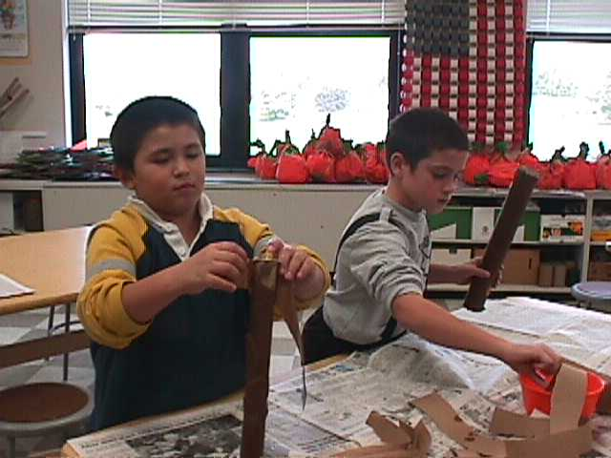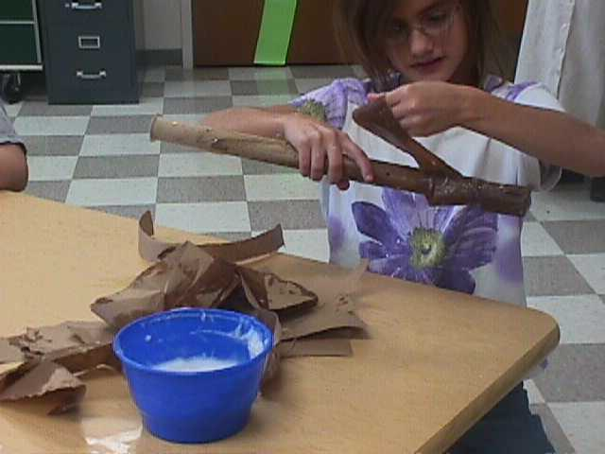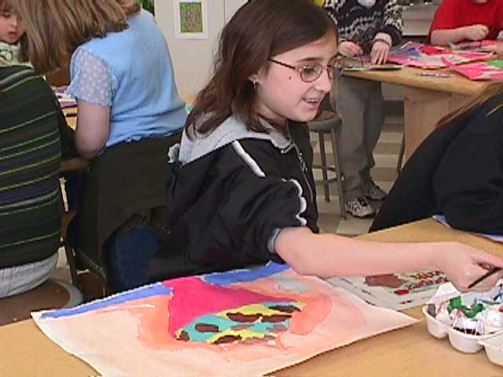
Chilean Rain Sticks; P.I. 2A, 2C, 3B, 4A Mixing Tints P.I. 1C

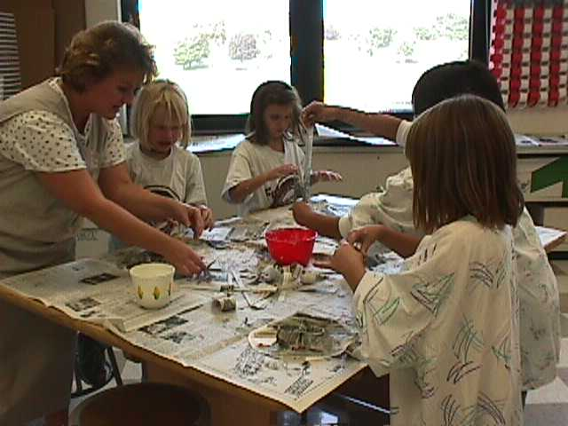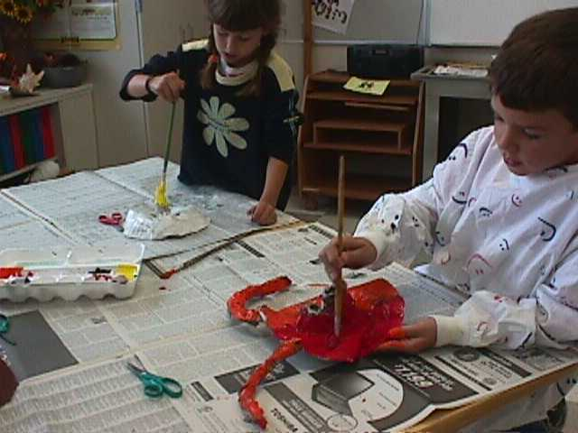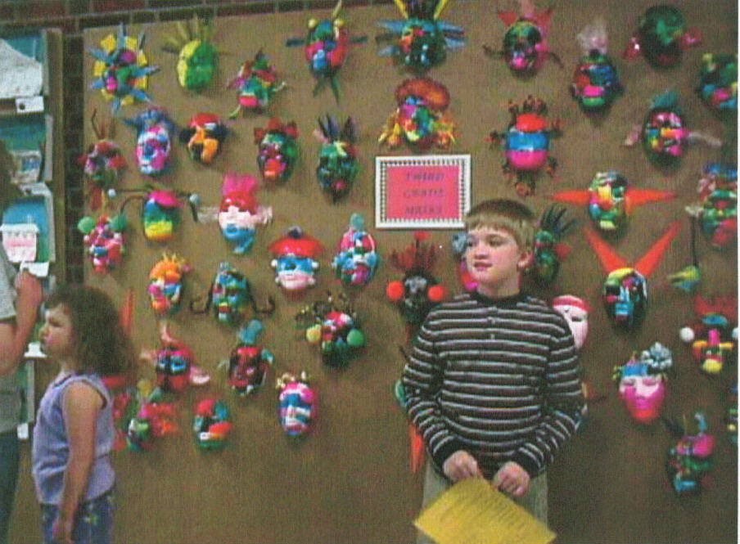
Masks; P.I. 1A, 1C, 1D

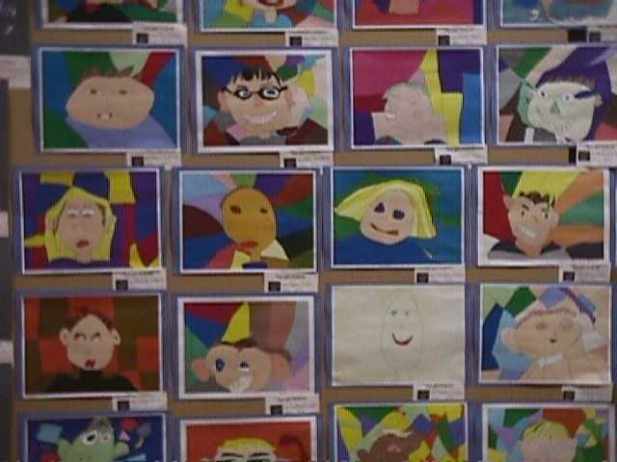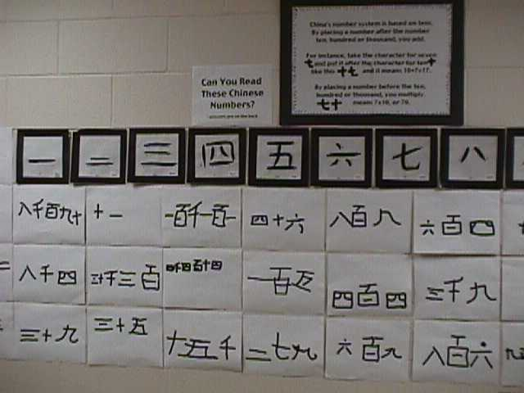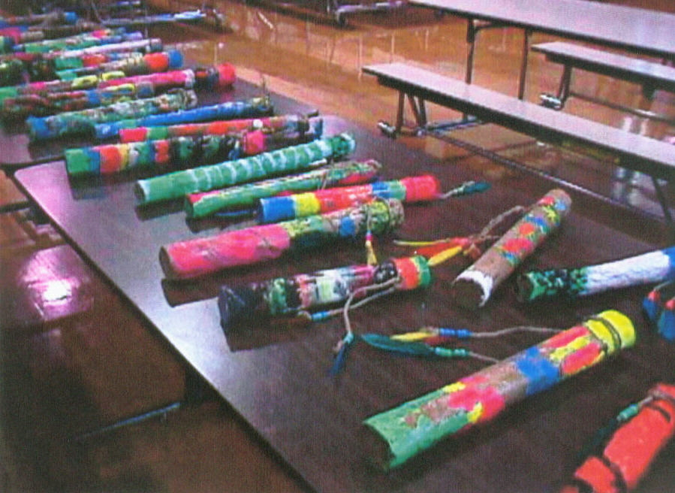
Cubistic Self Portraits Chinese Number Writing Chilean Rainsticks P.I.
Kid Pix P.I. 3D, 4C Integrated w/ 2A,C,3B,C,4B,C
P.I. 2B, 4A Integrated w/ SS 2i.1C Integrated ARTS M2.2B
MST 5.3B
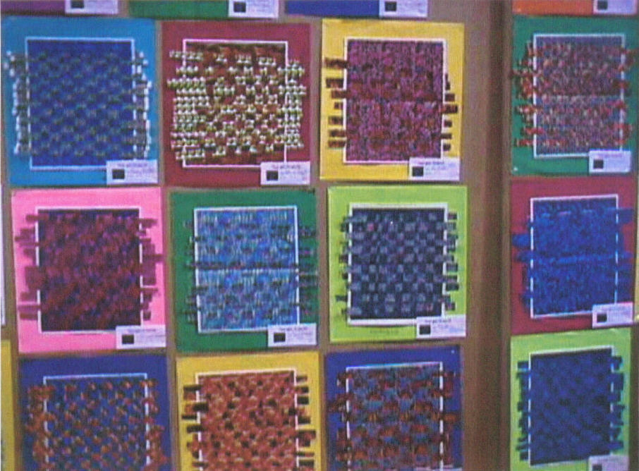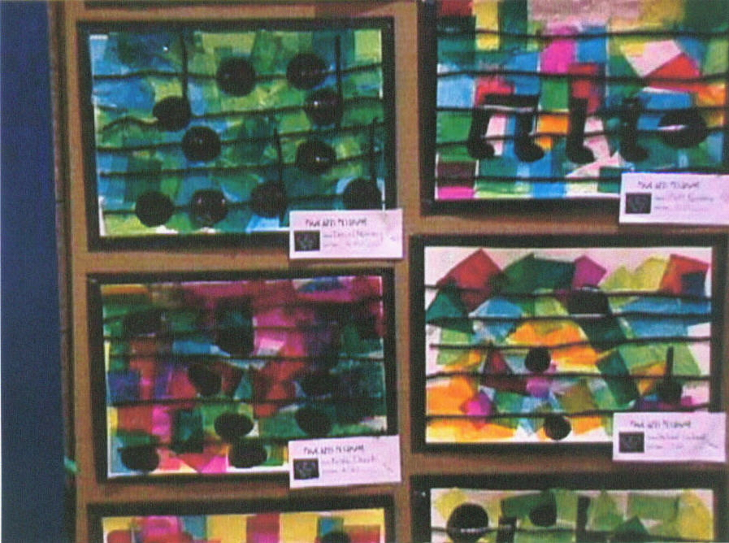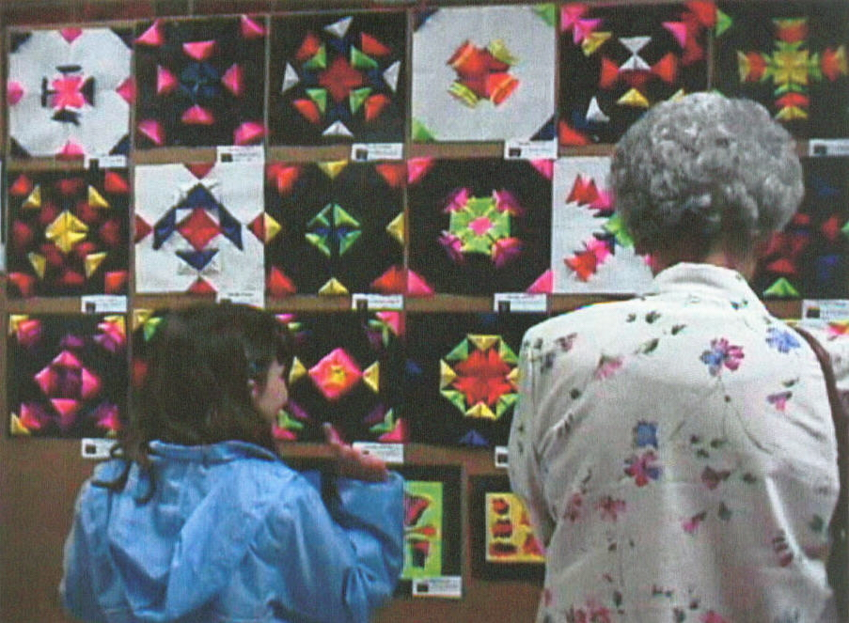
Textured Paper Weaving Combined media collage Design w/ Symmetry P.I.1A-D
Kid Pix 3 Integrated w/ P.I. 1A,C,D,3,A-C Integrated w/MST 3.4E, 3.7A
MST 5.3B
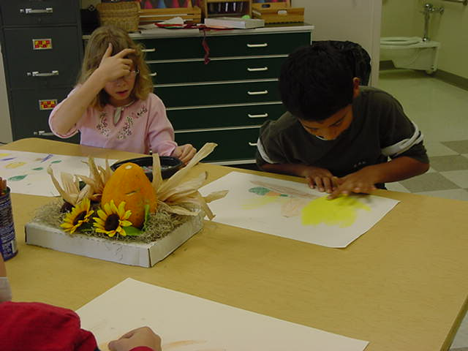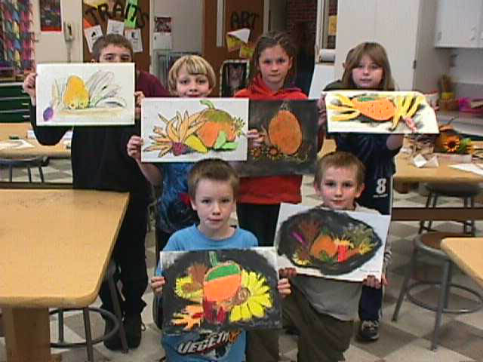
Still Life Drawing P.I.1A,C

Methodology: Kid Pix Deluxe 3, 6 Traits Writing, Library resources, Integration with Third Grade units and themes when possible. School Arts May/June 2003 issue.

